Project Design Phase-II
Technology Stack (Architecture & Stack)

Date | 5 July 2025
Team ID
Project Name | OptiCrop: Smart Agricultural Production Optimization Engine
Maximum Marks | 4 Marks

Technical Architecture:
The Deliverable shall include the architectural diagram as below and the information as per the table1 & table 2
Example: Order processing during pandemics for offline mode
Reference: https://developer.ibm.com/patterns/ai-powered-backend-system-for-order-processing-during-pandemics/

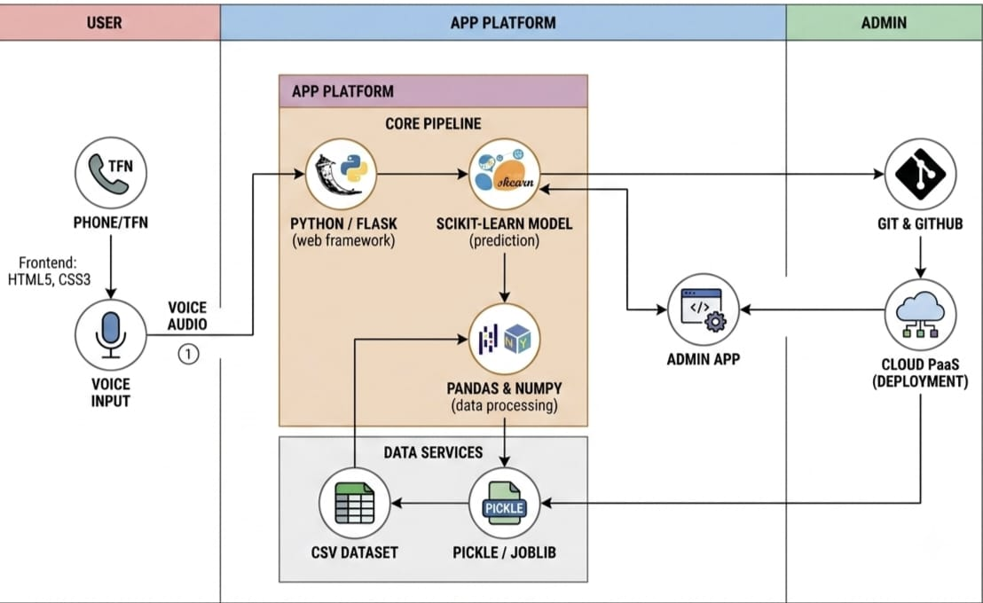

Table-1 : Components & Technologies:
S.No | Component | Description | Technology
 | User Interface | Farmers interact with the application through a web interface | HTML5, CSS3
 | Application Logic-1 | Handles user input, routing, and crop recommendation workflow | Python, Flask
 | Application Logic-2 | Performs data preprocessing and prediction using ML model | Python, scikit-learn, pandas, numpy
 | Application Logic-3 | Loads the trained model and generates crop recommendations | pickle / joblib
 | Database | Stores agricultural dataset used for model training and prediction | CSV Dataset
 | Cloud Database | Not used in current implementation | N/A
 | File Storage | Stores trained model and dataset files | Local File System (.pkl, .csv)
 | External API-1 | Live weather API integration (future enhancement) | OpenWeather API (Proposed)
 | External API-2 | Soil/Agriculture API integration (future enhancement) | N/A (Future Scope)
 | Machine Learning Model | Crop recommendation model trained on agricultural data | Python, scikit-learn
 | Infrastructure (Server / Cloud) | Application deployment and hosting | VS Code, Jupyter Notebook (Development), Git & GitHub (Version Control), Render / Heroku (Proposed Deployment)

Table-2: Application Characteristics:
S.No | Characteristics | Description | Technology
 | Open-Source Frameworks | Open-source frameworks and libraries used to build the application | Flask, scikit-learn, pandas, NumPy, HTML5, CSS3
 | Security Implementations | Basic input validation, secure Flask routing, HTTPS support during deployment, GitHub version control | Flask Security Features, HTTPS (Render/Heroku), Git & GitHub
 | Scalable Architecture | Modular architecture with separate frontend, backend, and ML model, allowing future scaling | Flask (3-layer architecture), Python
 | Availability | Web application accessible through cloud deployment; can be hosted for 24×7 availability | Render / Heroku (Proposed Cloud Deployment)
 | Performance | Lightweight Flask application with pre-trained ML model for fast predictions and efficient data handling | scikit-learn, pickle/joblib, pandas, NumPy

References:
https://c4model.com/
https://developer.ibm.com/patterns/online-order-processing-system-during-pandemic/
https://www.ibm.com/cloud/architecture
https://aws.amazon.com/architecture
https://medium.com/the-internal-startup/how-to-draw-useful-technical-architecture-diagrams-2d20c9fda90d

